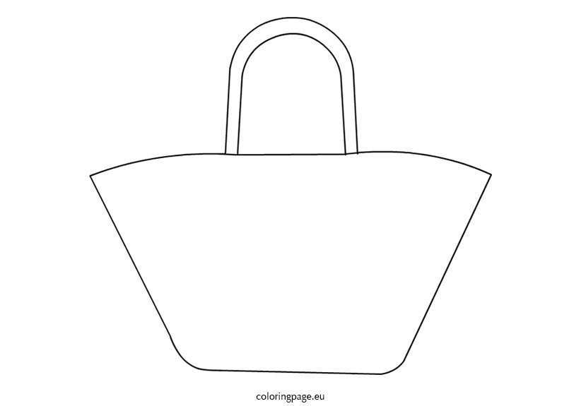

COMMUNICATION TOOLS E.G PICTURES/COMMUNICATION BOOK

**CUTLERY, CUP, BIB, FLUID THICKNER**

**(IF** NEEDED)

TELEPHONE NUMBERS OF YOUR IMPORTANT PEOPLE

**THINGS TO CALM ANXIETY- SOFT TOY, BLANKET, BOOK.**

CHANGE OF CLOTHES

CURRENT MEDICATION & MARS SHEET

ANY OTHER EQUIPMENT PERSONAL TO YOU, FOR COMFORT OR SAFETY

HEARING AID BATTERIES (IF NEEDED)

PADS (IF REQUIRED)

TOOTHBRUSH & TOOTHPASTE

**PBS PLANS**

**Where should your bag live?**

“Your bag should be kept somewhere that is easy to find in case someone else needs to bring it for you. A good place to keep your bag would be on a hook on the back of your bedroom door.”

**What is a ‘Hospital Grab Bag’?**

“A Hospital Bag is a bag which is full of emergency items in case you need to leave your home in an emergency. Having one of these will make a hospital trip easier.

**HOSPITAL PASSPORT**

**COVID-19 GRAB PASSPORT**

**EATING & DRINKING PLANS**

Learning Disability Acute Liaison Nurses:

Northumbria Healthcare NHS Foundation Trust:

0191 643 2487

Newcastle Upon Tyne Hospitals NHS Foundation Trust:

0191 282 0959

Imagine you are packing for a short holiday!